PROPOSAL PENELITIAN
SKEMA PENDANAAN:
PENELITIAN PEMULA

THE ROLE OF DIGITAL BUSINESS MODEL AS GROWTH ACCELERATOR TO MAINTAIN SMEs SUSTAINABILITY
Bidang Unggulan:
BU-6: Sosial Humaniora

Topik Penelitian:
T-6.2.1: Penguatan kewirausahaan, koperasi, dan UMKM

Pengusul :
- Nama: Nia Kurniati Bachtiar NIDN. 188508186 Fakultas: FEB
- Nama: Agus Setiawan NIDN. 158808135 Fakultas: Teknik

Dibiayai oleh Universitas Muhammadiyah Magelang dengan Anggaran Pendapatan dan Belanja Universitas (APBU) tahun akademik 2021.

Form/Unimma/STD/05.03-01-01
Dokumen ini merupakan bukti kinerja pemenuhan Sistem Penjaminan Mutu Penelitian Universitas Muhammadiyah Magelang

 | Standar hasil |  | Standar peneliti
 | Standar isi |  | Standar sarana dan prasarana
√ | Standar proses |  | Standar pengelolaan
 | Standar penilaian |  | Standar pembiayaan

UNIVERSITAS MUHAMMADIYAH MAGELANG
<JANUARI 2021>
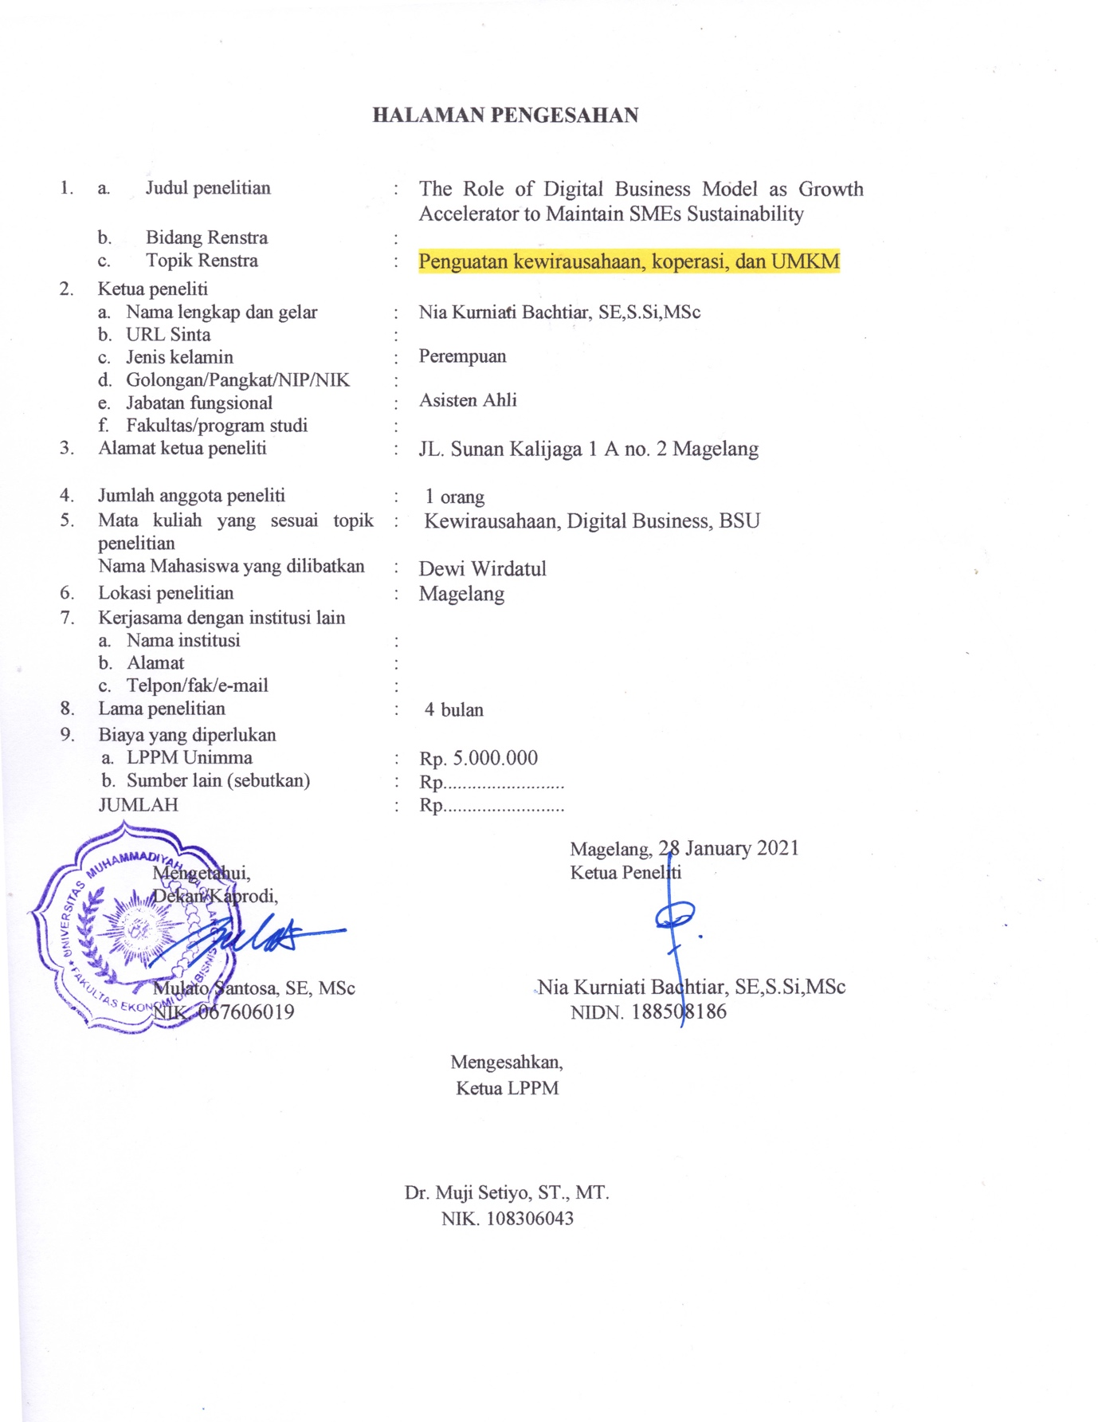

DAFTAR ISI

DAFTAR ISI 3
SUMMARY 4
BAB 1 PENDAHULUAN 5
1.1. Introduction 5
1.2. Research Aim 5
1.3. Research Contribution 6
1.4. Output Target 6
BAB 2 TINJAUAN PUSTAKA 6
2.1. Digital Imperative in Business 6
2.2. Digitalisation and Business Model 7
2.3 Business Model evolution 7
2.4 SMEs sustainability 8
BAB 3 METODE PENELITIAN 10
3.1. Research Method 10
BAB 4 BIAYA DAN JADWAL PENELITIAN 10
4.1. Jadwal Penelitian 10
4.2. Biaya Penelitian 11
DAFTAR PUSTAKA 12

SUMMARY
With an emerging need of digitalisation in business, all types and size of business are espected to impliment it in their daily operation, planning and strategy. Digitalisation is also becoming one potential sustainability weapon for business to survive in the market (Gregory and Hoffman, 2020), (Brenner, 2018), (Henrikson & Grunewald, 2020) due to its role in changing firms' business model and accelerate growth.

The aims of this research is to measure the relation between digital business model as growth accelerator to assist SMEs sustainability. This research will focus to SMEs as the milestone of economic growth in Indonesia. Data recorded that SMEs take 99.9% of type of business in Indonesia and contribute to 60.3% of Indonesia's Gross Domestic Bruto (GDB) (Kementrian keuangan, 2020), (Katadata, 2020). To be specific, this study will focus to SMEs in culinary industry which is the most operated SMEs in Indonesia (Cashlez, 2021)

In order to find a suitable model, quantitative and qualitative perspective will be used to analyse data and better approach for the research object. This research will focus in Magelang which have a high number of culinery business. This research article will be submitted to Journal of Entrepreneurship, Management and Innovation (JEMI).

PENDAHULUAN

Introduction
With an emerging need of digitalisation in business, all types and size of business are espected to impliment it in their daily operation, planning and strategy. Digitalisation is also becoming one potential sustainability weapon for business to survive in the market (Gregory and Hoffman, 2020), (Brenner, 2018), (Henrikson & Grunewald, 2020) due to its role in changing firms' business model and accelerate growth.
The research about technology implementation in business emerged since the blast of internet in early 2000 and rapidly increased this past decade. Data in 2017 indicated 53% business in the world both Large Organizations (LOs) and Small and Medium Enterprises (SMEs) have already depended their activities in technology and the usage of internet network (Insight, 2017) and this number is still enhancing. The most update data in 2018 indicated that more than two third businesses in the world are exploiting technology and internet usage in their daily activities (Genome, 2018). Following to that, number of technology based business establishment among business increases significantly these past years. This claim is proven by the data shown that technology based business especially technology based startup is escalating through years (Hudson, 2015), (Statista, 2017), GEM (2017). On the other hand, Jovkic et al (2018) underlined that high extend of technology development can be used to gain better market position and it is applied for all type of business.
Relationship between digitalisation and business model have been carried out by various researchers. Küfeoglu et al (2019) stated the rise of digitalisation such as Artificial intelligent, mechine learning, deep learning, blockchain application in business model of start-up energy companies. Kovaitė and Stankevičienė (2019) indicated the risks of digitalisation in business model include technical, competence, acceptance by staff, acceptance by customers and partners, data privacy and security and financial risks. Ahmad and murray (2018) declared the connection between digitalisation, sustainability and performance in large organisation. This research is strenghten by Brenner (2018) that claimed organizations can capitalize on dynamic transformative capabilities to generate novel value propositions by applying co-creation, usage-based pricing, agility, closed-loop processes, asset sharing, and collaborative business ecosystems. However, among all researches above, none of them use digitalisation as growth accelerator to SMEs business. as stated earlier, SMEs have a significant role in Indonesian economy, hence it is substantial to set a sustainability business model for SMEs.

Research Aim
This research aims to measure the relation between digital business model as growth accelerator to assist SMEs sustainability. This research will focus to SMEs as the milestone of economic growth in Indonesia. Data recorded that SMEs take 99.9% of type of business in Indonesia and contribute to 60.3% of Indonesia's Gross Domestic Bruto (GDB) (Kementrian keuangan, 2020), (Katadata, 2020). To be specific, this study will focus to SMEs in culinary industry which is the most operated SMEs in Indonesia (Cashlez, 2021)

Research Contribution
The contribution of this research as explain in figure below:
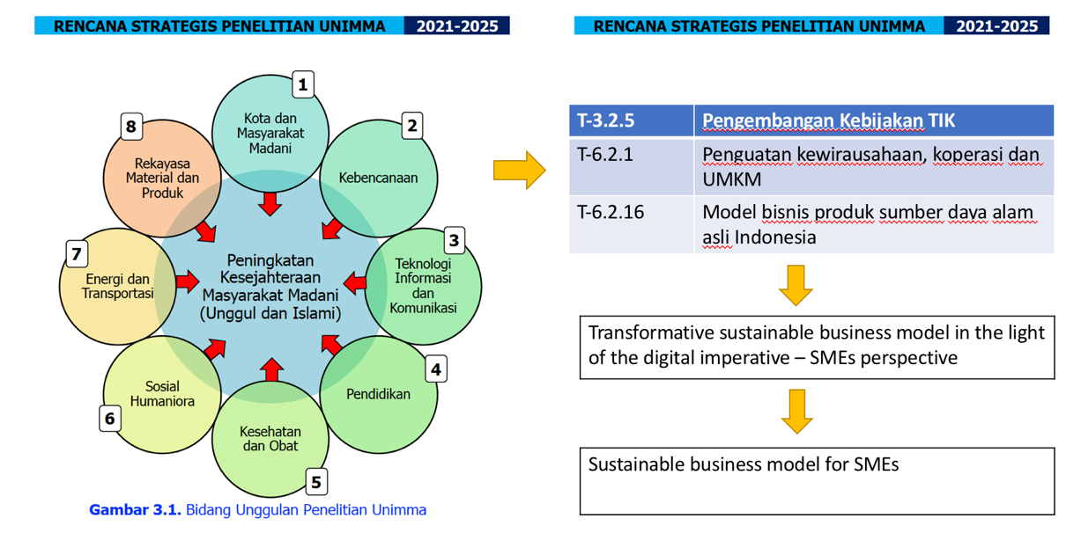

Output Target
This research article will be submitted to Journal of Entrepreneurship, Management and Innovation (JEMI) https://www.jemi.edu.pl

TINJAUAN PUSTAKA

Digital Imperative in Business
Digital imperative in business raises due to the high interdependency of businesses to technology. All types and size of business are implimented technology in their daily operation, planning and strategy. The usage of technology turns business to be digitalised. On the other hand, Digitalisation is also becoming one potential sustainability weapon for business to survive in the market (Gregory and Hoffman, 2020), (Brenner, 2018), (Henrikson & Grunewald, 2020) due to its role in changing firms' business model and accelerate growth.

The research about technology implementation in business emerged since the blast of internet in early 2000 and rapidly increased this past decade. Data in 2017 indicated 53% business in the world both Large Organizations (LOs) and Small and Medium Enterprises (SMEs) have already depended their activities in technology and the usage of internet network (Insight, 2017) and this number is still enhancing. The most update data in 2018 indicated that more than two third businesses in the world are exploiting technology and internet usage in their daily activities (Genome, 2018). Following to that, number of technology based business establishment among business increases significantly these past years. This claim is proven by the data shown that technology based business especially technology based startup is escalating through years (Hudson, 2015), (Statista, 2017), GEM (2017). On the other hand, Jovkic et al (2018) underlined that high extend of technology development can be used to gain better market position and it is applied for all type of business

Digitalisation and Business Model
Relationship between digitalisation and business model have been carried out by various researchers. Küfeoglu et al (2019) stated the rise of digitalisation such as Artificial intelligent, mechine learning, deep learning, blockchain application in business model of start-up energy companies. Kovaitė and Stankevičienė (2019) indicated the risks of digitalisation in business model include technical, competence, acceptance by staff, acceptance by customers and partners, data privacy and security and financial risks. Ahmad and murray (2018) declared the connection between digitalisation, sustainability and performance in large organisation. This research is strenghten by Brenner (2018) that claimed organizations can capitalize on dynamic transformative capabilities to generate novel value propositions by applying co-creation, usage-based pricing, agility, closed-loop processes, asset sharing, and collaborative business ecosystems..

2.3 Business Model evolution
There are countless Business Model (BM) worldwide. Every business shapes their own BM and makes it hard to define. Numerous researches have demonstrated the widely applied and evolution of BM since the creation, adaptation, reinvention to the innovation of business model (Morris, Schindehutte, & Allen, 2005), (Demil & Lecocq, 2010), (Chesbrough, 2010) (Zott, Amit, & Massa, 2011), (Trimi & Berbegal-Mirabent, 2012), (Foss & Saebi, 2015), (Weill & Woerner, 2015), (Sharma, Dixit, & Karna, 2016) (Landau, Karna, & Sailer, 2016), (Saebi, Lien, & Foss, 2017).
Morris, Schindehutte & Allen (2005) proposed framework to business model which include factor related to market factors, internal capability factors, competitive strategy factors, economic factors, growth/exit factors. Moreover, concept of business model develops over time in term of finding its dynamic consistency. Demil & Lecocq (2010) stated the different use of business model as static approach and transformational approach. Both approaches then employed in a framework consists of resources and competence, internal and external organisation, volume and structure cost, margin, volume and structure of revenue, value proposition. In line to it, the next research focus to several important elements in business model such as business activities and how value created within business (Zott, Amit, & Massa, 2011).
Through the dynamics of business world, BM is also changing. The adaptation of BM is unavoidable. Some drivers like changes of demand, response to external threats and opportunity, past strategic orientation, market development and BM adaptation (Sharma, Dixit, & Karna, 2016), (Saebi, Lien, & Foss, 2017). Specifically in emerging market which offer big opportunity to firms, BM adaptation is sometimes seen as competitive advantage and a challenge. Firm based in developed country needs to adapt their BM to suit to the nature of emerging market. There are stages need to be followed: international extension, local emergence, local expansion and local consolidation (Landau, Karna, & Sailer, 2016).
However, BM adaptation is not the final form of BM. It shifts and develops into BM innovation to construct a fit between BM dynamics include BM evolution, adaptation and innovation, environmental change and capabilities to achieve firm performance (Foss & Saebi, 2015), (Saebi, Lien, & Foss, 2017). BM Innovation (BMI) widely adapt in start-up process where boundaries need to be set and product/service need to be offered. This phase is quite complex especially to technology based business which need more funding than other types of business (Trimi & Berbegal-Mirabent, 2012). Due to strong relationship between innovation and technology, BMI raises digital business model. This BM has 3 (three) components namely content, customer experience and platform that enables firm to build its capabilities in digital world. Those 3 (three) elements may create a smooth customer journey and end up generating loyal customers. Hence, it is believed as digital strategy to build firms’ competitive advantage (Weill & Woerner, 2015).

2.4 SMEs sustainability
The sustainability of SMEs depends on the selection of their respective business growth strategies. The growth strategy chosen must be appropriate to the internal and external environment of the business. Milara (2014) wrote that the company's internal environment includes all resources owned by the company and the company's ability to manage these resources. These resources include all assets, knowledge, employees, information, organizational processes, capabilities, and activities that the business can carry out, such as marketing, sales, promotions, etc. While the external environment of the company includes economic, political, social, technological and the laws in force in the country where the business operates.
The external environment is just as important as the internal environment. The external environment can change the way people behave and their habits in buying certain products or using certain services. To find these external threats, the analysis made by Prof. Francis Aguilar in 1967 called PESTEL analysis is a suitable framework because it can describe all external problems that affect business strategy. PESTEL analysis can be seen in Figure 2.
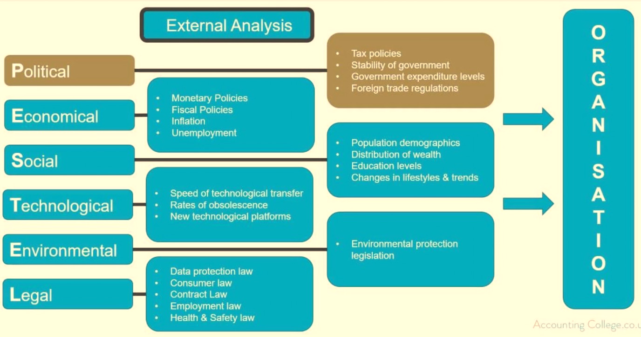
dss.
As seen above, PESTEL's analysis consists of six external elements: political, economic, social, technological, environmental, and legal, where each element consists of several points as described in the figure. These external elements force entrepreneurs to become more flexible and adaptable to survive in the industry.
In addition, MSMEs must cope with market uncertainty and instability. Market uncertainty and instability are caused by short product life cycles, short product design cycles, new technologies, frequent entry by unexpected products / services, repositioning by old companies, and radical redefinition (Soundararajan, 2016).
Based on this internal and external environment, suitable strategic steps can be established. These strategic steps will be carried out using internal resources, and strategies must be implemented based on the external environment (Boohawajan, 2017). The most common strategies applied by most businesses include marketing innovation and the pursuit of competitive advantage, promotion, and price (Naidoo, 2010). Ming Luo and Fan Chang (2011) add that the integration of internal and external research and development (R&D) strategies and reducing internal costs and time is also considered a strategic move in pursuing growth.
However, in order to survive in the industry, growth is not the only consideration on which MSMEs must focus. Another important issue that must be resolved by MSMEs is challenges, which (such as strategies) come from the internal and external environment. Darwanto (2012) argues that low technology capability, low awareness of business expansion through e-commerce, and low ownership of international and national certifications can be internal obstacles in maintaining the business life cycle and surviving in the industry. Finally, challenges from the external environment can stem from regulation, infrastructure, and market access (OECD, 2000).

METODE PENELITIAN

Research Method
As a mixed method approach, this research collect and analyse data using 2 ways, quantitative and qualitative. Data taken for quantitative approach is using questionnaire. validity and reliability tests are carried out as well as multiple regression analysis. For the qualitative approach, structured interview will be carry out to research samples. This research applies Purposive sampling to limit the research object. The categories cover culinary business, permanent place (not mobile) and establish more than 2 years.
Mix method analysis is suitable to be amplimented in this research due to its flexibility in testing hypoteses and getting deeper findings for the problem solving (O'Cathain & Murphy, 2007). Below in the research method of this research
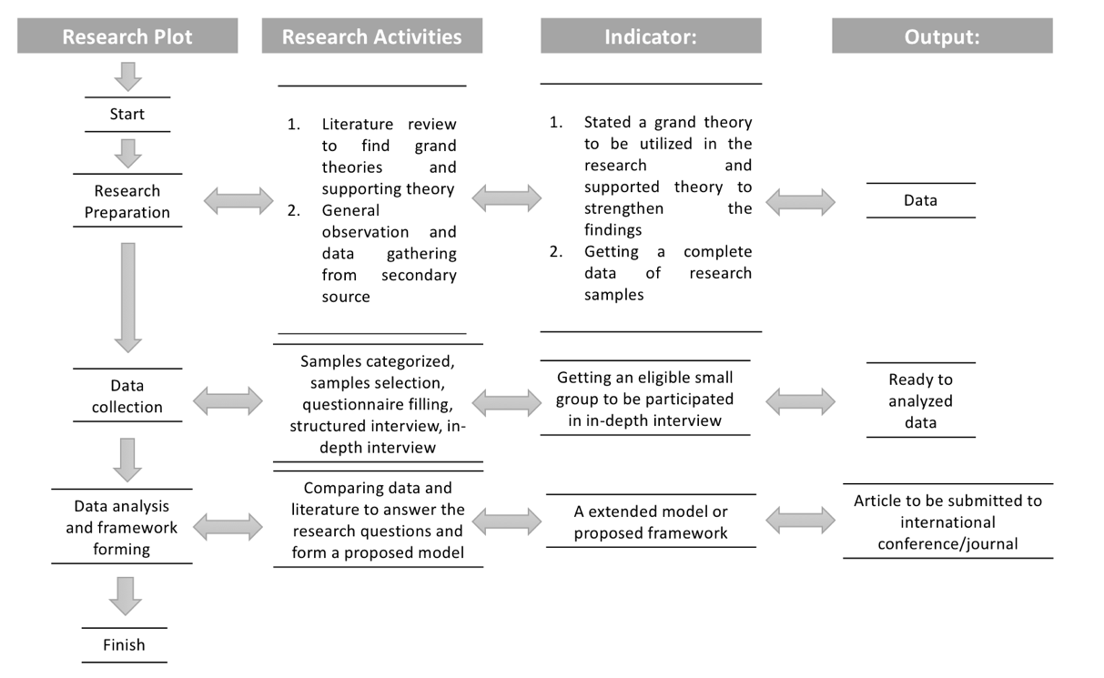
Figure 2. Research method

BIAYA DAN JADWAL PENELITIAN

Jadwal Penelitian
Tabel 4.1. Jadwal penelitian
No | Kegiatan | Bulan penelitian
 |  | ke 1 | ke 2 | ke 3 | ke 4
 | Persiapan Penelitian | V
 | Pengumpulan Data dan FGD |  | V
 | Analisa Data |  |  | V
 | Penyusunan Laporan dan Artikel Ilmiah |  |  |  | V

Biaya Penelitian
Tabel 4.2. Rancangan anggaran penelitian
Kegiatan A: Persiapan Penelitian
Jenis | Pembelanjaan | Jumlah | Harga (Rp) | Total (Rp)
Bahan | Paket Internet | 2 paket | 100.000 | 200.000
Bahan | Pulsa | 1 paket | 100.000 | 100.000
Bahan | Konsumsi | 4 paket | 40.000 | 160.000
Sub total kegiatan A |  |  |  |  | 460.000
Kegiatan B: Pengumpulan Data dan FGD
Jenis | Pembelanjaan | Jumlah | Harga (Rp) | Total (Rp)
Bahan | Paket Internet | 2 paket | 100.000 | 200.000
Bahan | Pulsa | 1 paket | 100.000 | 100.000
Bahan | Konsumsi | 12 paket | 40.000 | 480.000
Kegiatan C: Analisa Data
Bahan | Paket ATK | 1 Paket | 500.000 | 500.000
Bahan | Pulsa | 1 paket | 100.000 | 100.000
Honorarium | Olah Data | 1 paket | 500.000 | 500.000
Sub total kegiatan B dan C |  |  |  |  | 1.880.000
Kegiatan D: Luaran Penelitian
Jenis | Pembiayaann | Jumlah | Harga (Rp) | Total (Rp)
Bahan | Paket Internet | 4 paket | 100.000 | 400.000
Bahan | Pulsa | 1 paket | 100.000 | 100.000
Bahan | Konsumsi | 4 paket | 40.000 | 160.000
Biaya Output | Artikel Ilmiah Internasional | 10 lembar | 200.000 | 2.000.000
Kegiatan D |  |  |  | 2.660.000
Total usulan biaya (A+B+C+D)= Rp. 5.000.000,-

DAFTAR PUSTAKA

Chesbrough, H. (2010). Business Model Innovation: Opportunities and Barriers. Long Range Planning, 354-363.
Demil, B., & Lecocq, X. (2010). Business Model Evolution: In Search of Dynamic Consistency. Long Range Planning, 227-246.
Foss, N., & Saebi, T. (2015). Business Model Innovation: The Organizational Dimension. Oxford: Oxford University Press.
Genome, S. (2018). Global StartUp Ecosystem Report 2018. -: Startup Genome.
Hudson, M. (2015). Forbes. Retrieved March 6, 2019, from https://www.forbes.com/sites/mariannehudson/2015/06/22/new-report-confirms-startup-activity-increasing-after-years-of-decline/#5a2057fb6f10
Insight. (2017). Insight.com. Retrieved November 21, 2018, from https://www.insight.com/en_US/learn/content/2017/02232017-these-small-business-technology-statistics-are-surprising.html
Landau, C., Karna, A., & Sailer, M. (2016). Business model adaptation for emerging markets: a case study of a German automobile manufacturer in India. R and D Management.
Morris, M., Schindehutte, M., & Allen, J. (2005). The entrepreneur's business model: toward a unified perspective. Journal of Business Research, 726-735.
O'Cathain, A., & Murphy, E. (2007). Why, and How, Mixed Methods Research Is Undertaken in Health Services Research in England: A Mixed Methods Study. BMC Health Services Research 7(1), 85.
Saebi, T., Lien, L., & Foss, N. J. (2017). What Drives Business Model Adaptation? The Impact of Opportunities, Threats and Strategic Orientation. Long Range Planning, 567-581 .
Sharma, S., Dixit, M. R., & Karna, A. (2016). Design leaps: business model adaptation in emerging economies. Journal of Asia Business Studies , 105-124.
Statista. (2017). Statista. Retrieved March 6, 2019, from https://www.statista.com/topics/4733/startups-worldwide/
Trimi, S., & Berbegal-Mirabent, J. (2012). Business model innovation in entrepreneurship. International Entrepreneurship Management Journal, 449–465.
Weill, P., & Woerner, S. (2015). OptimizingYour Digital Business Model. MIT SLOAN MANAGEMENT REVIEW, 28-35.
Zott, C., Amit, R., & Massa, L. (2011). The Business Model: Recent Developments and Future Research. Journal of Management, 1019-1042.

