EXPECTATION AND SATISFACTION LEVEL IN WOMEN SANITARY PADS IN MAGELANG, INDONESIA

Marlina, Kurnia

Universitas Muhammadiyah Magelang, Indonesia

marlinakurnia@ummgl.ac.id

Nia Kurniati, Bachtiar1

Universitas Muhammadiyah Magelang, Indonesia

niakurniatibachtiar@ummgl.ac.id

Abstract—Expectation as a future prediction of certain product always set by costumers in their pre-purchasing behavior. This expectation will lead to the costumers purchasing decision and direct them to the satisfaction level expected by consuming that particular product. This research which focus to the relationship between expectation and satisfaction tested the hypothesis: There is mutual relationship between expectation and satisfaction level in purchasing a product with the research question as follow: is customer satisfaction able to fulfil customer expectation?. This research focused in women sanitary pads in Indonesia which limited to the top three brand index in sanitary pads in Indonesia. As expected, the result of the research supported the hypothesis
Keywords—Expectation, Satisfaction, Costumers, women sanitary pads

Introduction
The strong need leads people to strong willingness to possess or utilize any particular things or products. The level of needs from least important, important to massive important level creates different decision of buying, order or even possess something. This opportunities then mobilized by various company in the world in creating and establishing different product based on the level of needs. In fact, due to the rapid changing of the modern world where technology and innovation take the significant role in creating more complexity world, the challenge and opportunities arise at the same time.

People experienced the simplicity of the world economic when the only substantial needs are food, clothing and housing. However, the development in 21st century expands those needs to the level that difficult to stop. This statement is strengthen by the changing of the hierarchy of needs framework created by Abraham Maslow (1943) that mentioned 5 level of human needs which are: psychological, safety, love/belonging, esteem, and self-actualization (Maslow, 1943) - to the modern hierarchy of needs proposed by Bronco (2015) that completed and updated those needs into 6 level of needs where connectivity became one of them (Bronco, 2014).

Talking about needs, the expanding of needs creates the improvement level of people expectation of a product or service they desire. With the various products provided in the industry, people as customers have a certain bargain power in order to keep using, be loyal or shift to another product. This statement explained in Michael Porter’s model that well-known as Porter’s Five Forces (Porter, 1998).

Thus, this article will discuss about the satisfaction level and the customers expectation of the certain product. This article will focus to a significant product needed by woman worldwide which is sanitary pads. Even though sanitary pads were necessary for women, history recorded that the rising of disposable sanitary pads or menstrual pads had just started in late 1800s. Before that, women used cotton, rags or wool that difficult to dispose. However, with the rapid change of technology, since 1980s, women worldwide could easily find various type of sanitary pads around them (Sabrina, 2013). This development was enrich with the massive increasing in product innovation completed the technology used to finally created more sophisticated pads like we can see nowadays.

Nevertheless, the problem appears due to the numerous brand of sanitary pads in the market. Related with the Maslow model and Potter framework mentioned previously, customers have a significant power to choose which brand that suit them well and the level of satisfaction they expect from that product. the level of expectation and satisfaction will differ based on the brand. The high expectation is usually emerged in the usage of high quality or top brand. Customers will anticipate more from top brand product and vice versa. However, the reality sometimes prove differently where the top brand product sometimes deliver less satisfactory product than the new entrants. Hence, this article will measure the level of expectation and customers satisfaction of 3 sanitary pads top brand in Indonesia which are: Laurier, Charm and Softex.

Those brands lead the women sanitary pads market in Indonesia in 2017 where Charm placed first with 47 % in top brand index, followed by Laurier with 37.2% and lastly, Softex gained 10.7% (Award, 2017). Looking at that position, people may easily assume and expect that those 3 brands deliver the most satisfaction product among others in the sanitary pads market. Thus, this research intends to prove the consumers assumption with aims as follow: to reveal the expectation and satisfaction level of the costumers to those 3 top brands of sanitary pads. Next, to discover what aspect drive the customers satisfaction to those brands.

LITERATURE REVIEW

Expectation and satisfactory level have been discussed broadly by (Cardozo, 1965), (Westbrook & Reilly, 1983), (Thomson & Sunil, 1983), (Caluarna, 2002), (Ryzin, 2004), (Liai, Chena, & Yen, 2007) and (Kim, 2010)

Table 1. Previous articles related to the conducted research.
Author | Articles
 | Title | Research Objectives
Richard N. Cardozo (1965) | An Experimental Study of Customer Effort, Expectation, and Satisfaction | Laboratory experiment based research that discover that the satisfaction level of customers for certain products was influenced by the extra effort to gain the product and the level of expectation of the products.
Westbrook and Reilly (1983) | Value-Percept Disparity: An Alternative To The Disconfirmation of Expectations Theory of Consumer Satisfaction | The needs of conceptual framework in order to confirm the expectation paradigm and satisfaction level of customers. This article proposed the extended theory in measuring the satisfaction and expectation.
Andrew Thomson, Rosa Sunol (1995) | Expectations as Determinants of Patient Satisfaction: Concepts, Theory and Evidence. | The research discovered the relationship between satisfaction and expectation and revealed the important personal and social variables that related to both elements. The research concluded that expectation can be used to understand the level of satisfaction.
Albert Caluarna (2002) | Service Loyalty: The Effects of Service Quality and The Mediating Role of Customer Satisfaction | The article underlined the concept of service loyalty to customer satisfaction. It found out that customer satisfaction plays a substantial role in service quality.
Gregg G. Van Ryzin (2004) | Expectations,performance, and citizen satisfaction with urban services | The article focused in expectancy disconfirmation model on customer satisfaction in urban service. It revealed that the model plays a fundamental role in formatting the satisfaction judgement. This article proposed that managers should promote high expectation rate, not only high-quality service.
Chechen Liao, Jian-Liang Chen, David Yen (2007) | Theory of Planning Behavior (TPB) and customer satisfaction in the continued use of e-service; An Integrated Model | This article developed an integrated model in predicting and explaining the satisfaction using expectation disconfirmation model and the theory of planned behavior.
Kim Buyoungsoo (2010) | An Empirical Investigation of Mobile Data Service Continuance: Incorporating the Theory of Planned Behavior into the Expectation-Confirmation Model | This study proposed an integrated model to predict customers loyalty using the expectation confirmation model. This study discovered that besides the expectation model, subject norm, perceived behaviour control also possess significant meaning in creating loyal customers.

How Expectation affect Purchasing

The relationship between expectation and purchasing has been delivered clearly in previous articles elicited above. However, they have not explicitly mentioned how expectation formed in customers mind and which elements shape and create this expectation that in the end become the major reason of purchasing.

Expectation has a direct relationship to the concept of trust. In fact, expectation is the outcome of the trusting process that happen in people mind which resulted from the combination of interpretation and suspension (Möllering, 2001). Following to that, expectation is happening from people’s nature and their unconscious mind that drive into the decision of choosing the kind of expectation will be expected by them, either it is positive or negative expectation or in the other hand, either it is low expectation of high expectation.
Connect that to the customer expectation, as a person, customer also gains the expectation of certain product from his/her nature and unconscious mind. This expectation then shifts into motivation of purchasing by constructing the effort to contribute in purchasing process and decision. Hence, Victor Vroom’s expectancy theory (1975) explained three major elements that motivate ones in doing things or on the other hand, elements that motivate customers in purchasing something. They are: valence which measure the value attached to a product, then expectancy that measure the confidence of customer of perceived expectation and lastly, instrumentality that measure the believe developed from expected promise. The expectancy theory illustrated in figure 1 below:

Figure 1. Vroom’s Expectancy theory
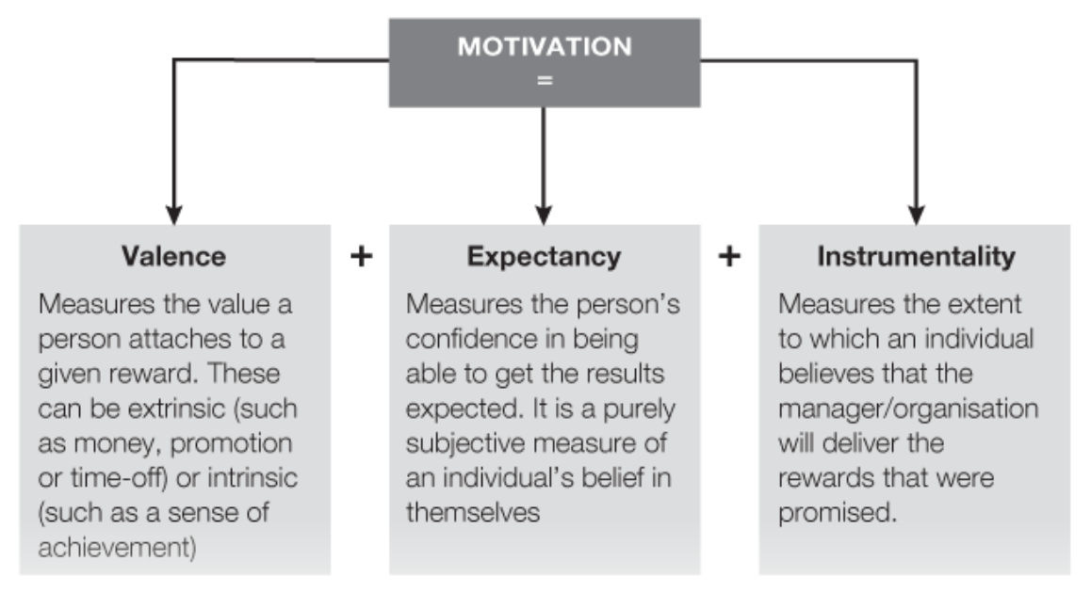
Source: (Bates & Mcgrath, 2013)

Thus, it is clearly stated that expectation is a core elements in motivating particular customer to purchase certain product. Hence, the way expectation influence purchasing can be specified based on the model above.

How Purchase Turn into Satisfaction

The major result a company intends to have after the product sold is the satisfaction of the customers. This essential element depends not only to the quality of product itself but due to more complex causes. Indeed, the product quality becomes the first consideration to trigger customer satisfaction. However, it is not the only one, various aspects also play an important role in creating satisfaction such as: accessibility, product value, service, responsibility of the company and else (institute, 2018).

Hence, to shift the purchasing into satisfaction, a company needs to understand the elements that influence it. Figure 2 below is the model of Costumers Satisfaction Index (CSI) that shows the 5 significant aspects that generate costumers satisfaction.

Figure 2. Costumers Satisfaction Index (CSI) Model
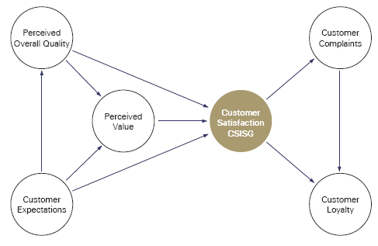
Source: (Deng, Yeh, & Sung, 2013)

Above model explains that customer satisfaction is driven by overall quality of the products, customer expectation, customer complaints and customer loyalty. Without one of them, the level of satisfaction will be decreased and there is a huge possibility that customers satisfaction will not be fulfilled when company puts one of the elements aside.

How Satisfaction Fulfil the Expectation

This research argued that there is a mutual relationship between satisfaction and expectation. Not only expectation causes satisfaction as illustrated in the model above. However, both aspects relate each other in a way that one aspect may develop and increase the other or on contrary, one aspect is able to bring down or decrease the performance of other aspect.

The data collection for this research results that the respondents have their own expectation of a product before purchasing it. Naturally, customers will predict how a certain brand can fulfil their satisfaction. This prediction called expectation. That expectation always appear due to several influences as mentioned by Engler et al (2015) such as: average score of previous rating, price and brand reputation (Engler, Winter, & Schulz, 2015).

Following to that, this pre-purchase behaviour strongly affect the purchasing decision whether they will buy a certain product or not. This behaviour also will lead to the post-purchasing satisfaction to finally develop loyalty to the company or product (Oliver, 1980). Therefore, the company marketer should set and predict the expectation level company expect from customers for particular product, especially if the company plans to launch a new product. This step will not fully guarantee the maximum satisfaction. However, this would be the best way company can propose to gain high customer satisfaction. As argued by Westbrook and Reilly (1983) that setting high level of expectation will not directly result high level of satisfaction. The expectation model fails to make clear prediction about that.

METHODOLOGY

Population and sampling
Population is a major need in conducting a research because this population will be utilised as a research object and influence the research result. The population of this research take from women as the user of this product. this population then limited based on the age where only productive age is included in the research object. Badan Pusat Statistik (BPS) Indonesia or Statistic Centre in Indonesia recorded that there are 32.984 women in Magelang city where this research conducted (BPS, 2018). Specifically for this research, we only take 100 respondents as sample.

After taking and selecting the respondents and samples. Techniques or method used in the research need to be decided. For this research, techniques or method utilized is Accidental Sampling. Vogt (2005) claimed that accidental sampling is a method where researcher selected the sample by conducting an interview to the first 100 people researcher meet (Vgot, 2011). By running this kind of method, researchers have their own privilege to select the respondents based on the time order they meet them.

Analysis Tools
This data analysis used expectation and satisfaction level quadrant gained from the customers as cited by Kotler (1996) in Freddy Rangkuti (2010). This expectation and satisfaction level is shown in a 4 column matrix that consist of 4 (four) quadrant as illustrated in figure below:

Figure 3. Expectation Level Matrix
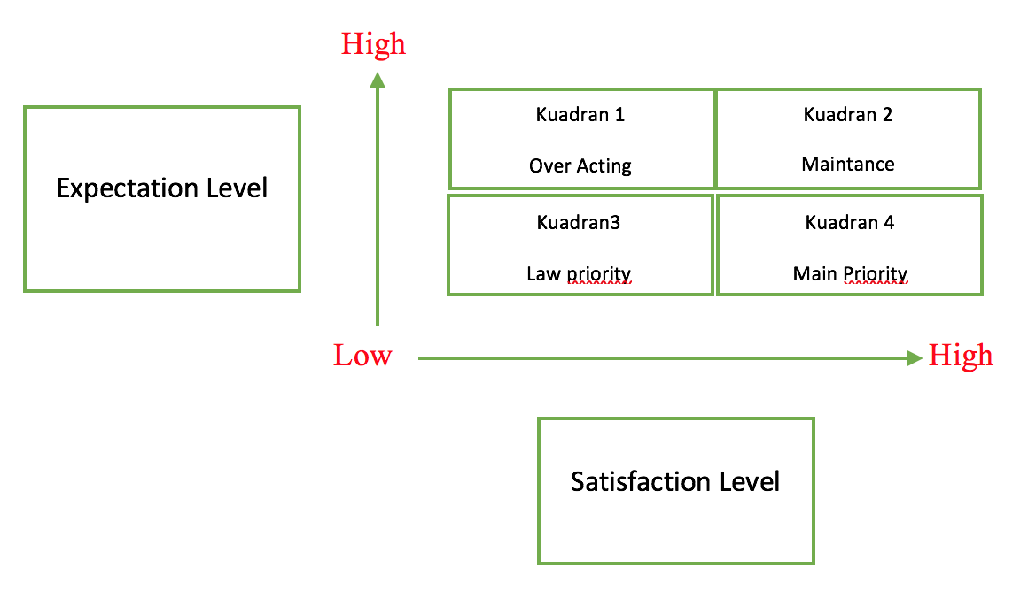

As stated in figure above, the matrix consists of 4 quadrant, which are: Over acting in quadrant 1, maintenance in quadrant 2, low priority in quadrant 3 and main priority in quadrant 4.

Quadrant 1.
In this quadrant, customers expectation level is actually high which means that customers expect to have a high quality product. However, the reality shows on contrary, where the significant factors considered by customers are unsuitable with their expectation. Hence, company needs to concentrate to those significant variables to achieve real progress

Quadrant 2.
This area is the most targeted area where expectation and satisfaction factors considered by customers are all achieved. Thus, all variables included in this quadrant need to be maintained in order to shape, create and develop company’s competitive advantage

Quadrant 3.
This quadrant consist of least important variables both for customers expectation and the satisfaction. It means that, variables in this quadrant are assumed to be least substantial so that they created low expectation and common satisfaction level to customers. The factors included in this quadrant can be eliminated due to their low contribution in product benefit.

Quadrant 4.
Here is the area which consist of unnecessary factors for the customers. However in the same time, they are delivered excessively by companies. Cost saving will be seized if companies decide to decrease them.

Reseach Varibles

Research variables are substantial due to their importance in data processing, analysis, research result and finally to test the hypothesis made before. Here are the research variables for this research:

Table 2. Research Variables

Brand | Research Variables
 | Quality | Design or Model
Charm,  Laurier,  Softex | Pads durability  (is it break easily?) | Packaging
 | Pads absorption  (is it absorb easily?) | Size
 | Pads perforated durability  (is it easily perforated?) | Thickness
 | Pads adhesion  (does it have a strong adhesive performance?) | Color
 | Pads surface  (does it have a soft surface?) | Accessories
Pads coolness
(is it cool to use?)
Pads crumple
(is it easily crumple?)

Meanwhile, the measurement scale employed is using linkert scale 1 to 5, as follow:
Satisfaction level
1 Poor
2 Fair
3 Average
4 Good
5 Excellent

Expectation level:
1 Very insignificant
2 Insignificant
3 OK
4 Significant
- Very Significant

ANALYSIS AND DISCUSSION

Profile of 100 respondents collected is as follows: 25 respondents are Laurier customers, 25 respondents are Charm Customers, 25 respondents are Softex customers and 25 respondents are other brand customers.
Table 3. analysis result

No | Variables
 |  | Satisfaction | Expectation
 | Expectation
 | Quality
1 | Pads durability | 77,4 | 84
2 | Pads absorption | 80,4 | 87,4
3 | Pads perforated durability | 79,2 | 87,2
4 | Pads adhesion | 76,6 | 82,4
5 | Pads surface | 73,8 | 79,8
6 | Pads coolness | 69,8 | 76,6
7 | Pads crumple | 75,4 | 84,6
 | Design/model
8 | Packaging | 69,8 | 70,2
9 | Size | 76,2 | 79,4
10 | Thickness | 76 | 78,8
11 | Colour | 65,8 | 66,4
12 | Accessories | 81,4 | 83,6
 | Total Score | 901,8 | 960,4
 | Average Score | 75,15 | 80,03

Table 3 above shows the results of variable values of expectations and customer satisfaction of sanitary pads for all brands, obtained by an average value of expectations of 80 while the average value of satisfaction is 75,15
From table above, the Customer Satisfaction and Expectation Matrix is obtained in figure 4 below where The first quadrant is located on the top left, the second quadrant is located on the upper right, the third quadrant is located on the lower left and the fourth quadrant is located on the lower right

Figure 4. Satisfaction and Expectation Matrix

Quadrant 1
Customers’ satisfaction is still low. There is not a single variable in this position. It means that all Laurier, Charm, Softex and other brands customers have low satisfaction and high expectations. . Then, there are no variables that fall into the category that meets customer expectations.

Quadrant II
In this quadrant, the value expected by customers and customer satisfaction is appropriate, then the variables that fall into this category must be maintained, because these variables created competitive advantage to the customers. From the above matrix there are several variables namely;
- Variable 1 - the resistance of the bandage and durability, can be knotted under the bandage, product is not easily torn
- Variable 2 - the absorption, it can be concluded that the bandage is easy to absorb liquid
- Variable 3 - the perforated durability, that is the liquid does not perforate easily from the pads used
- Variable 4 - the adhesion power, can be interpreted that strong adhesive tape does not easily shift from its position
- Variable 7 – the crumple power, it can be concluded that the product is very good because it is not easy to shrink or change when used.
- Variable 12 – the accessories / wings, wings are an accessory variable, there are right and left wings, to prevent leakage or expansion of fluid. So the customer feels comfortable with the wings.

Quadrant 3
In quadrant 3, variables are considered less important or the value of customer expectations and customer satisfaction is normal or not special. In this quadrant, the expectation value is low and the satisfaction value is also low. Or it can be said that this variable is not so important. From the results of the analysis of the respondents the sanitary pads studied were 3 variables:
- Variable 5 – surface variable of the pads, that is, the customer has a low expectation of the softness of the pads surface.
- Variable 6 - coolness, this can mean that the coolness of the pads is not the customer's expectation in using them.
- Variable 8 - Packaging, this can be interpreted as saying that the respondent does not prioritize packaging of sanitary pads, whether directly packaged or packaged with secondary packaging.
- Variable 11 - color variable, it can be concluded that any color is not a problem because when it is worn, the dressing is not visible from the outside.

Quadrant 4
Quadrant 4 contains of the value of low expectations for customers, but in reality customer satisfaction is very excessive. Variables that include this quadrant can be considered to be reduced so that companies can save costs. From the table above can be concluded that customers have low expectations on variables:
- Variable 9 - size variable, according to the customer the size of the size is not a problem, as long as the size used is normal, and does not interfere with activity, which is not very small and not very large.
- Variable 10 - the thickness variable, meaning that the customer ignores the thickness of the pads

RESULT AND SUGGESTION

In the earlier part of this article has been stated that customers expectation of a certain product may be able to drive them to purchase that product. the purchasing then will lead to satisfaction level of the customers. Previous articles mentioned in the literatures review supported that statement and this research as expected, strengthen that finding that in women sanitary pads the relationship between expectation, purchasing and satisfaction also show positive signal. Following to that, cited Vroom’s expectation theory, this research indicated that customers also follow the 3 (three) elements that motivate respondents to purchase sanitary pads. They are: valence, expectancy and instrumentality. These elements play a substantial role in customers mind and finally guide them to purchasing process.

Next, to turn purchasing into satisfaction as described in CSI model above, company needs to assure that these 5 (five) factors have been fulfilled. The factors are: overall quality of the product, customer expectation, perceived value, customers complain, and customers loyalty. Related to this research, in order to fulfil the CSI model described earlier, company should pay a great attention to the factors found in the data analysis. From the analysis conducted in this research, it can be concluded that the high customer satisfaction of product quality include: the variable durability of the pads, absorbency of the pads, durability, adhesion and accessory design of the variable size and thickness, while low satisfaction on product quality include: coolness, softness of the surface and accessory and color but this is not a problem because the customer has low expectations on these four variables.

Overall, the research positively proved the hypothesis made for this article. The suggestion made for this article is that company still need to drag the factors in quadrant 3 and make it considerably more important to the customers so that, those factors can be placed in quadrant 2. For the future research, it is necessary to have a comparing performance among those top three women sanitary pads to be able to draw more in-depth conclusion and discover different elements that affect different brand.

Bibliography
Award, T. B. (2017, - -). Top brand award. Retrieved from Top brand award: http://www.topbrand-award.com/top-brand-survey/survey-result/top_brand_index_2017_fase_1
Bates, B., & Mcgrath, J. (2013). The little book of big management theories : ... And how to use them. Harlow: pearson education limited.
Bronco. (2014, aPRIL 16). Bronco. Retrieved from Bronco: https://www.bronco.co.uk/our-ideas/modern-day-maslows-hierarchy-of-needs/
Caluarna, A. (2002). Service loyalty: the effects of service quality and the mediating role of customer satisfaction. European journal of marketing, 36(7/8, 811-828.
Cardozo, r. (1965). An experimental study of customer effort, expectation, and satisfaction. Journal of marketing research, 244-249.
Deng, W., Yeh, M., & Sung, M. (2013). A customer satisfaction index model for international tourist hotels: integrating consumption emotions into the american customer satisfaction index. International journal of hospitality management, 35(-), 133-.
Engler, T., Winter, P., & Schulz, M. (2015). Understanding online product ratings: a customer satisfaction model. . Journal of retailing and consumer services, 27(-), 113-120.
institute, N. b. (2018, - -). National business research institute. Retrieved from National business research institute: https://www.nbrii.com/customer-survey-white-papers/10-factors-that-affect-customer-satisfaction/
Kim, B. (2010). An empirical investigation of mobile data service continuance: incorporating the theory of planned behavior into the expectation–confirmation model. Expert systems with applications, 37(10), 7033-7039.
Liai, C., Chena, J., & Yen, D. (2007). Theory of planning behavior (tpb) and customer satisfaction in the continued use of e-service: an integrated model. . Computers in human behavior, 23(6), 2804-2822.
Möllering, G. (2001). The nature of trust: from georg simmel to a theory of expectation, interpretation and suspension. . Journal of sociology, 35(2), 403-420.
Maslow, A. (1943). A Theory of HUman Motivation. Midwest: Createspase Independent Publishing.
Oliver, R. (1980). A cognitive model of the antecedents and consequences of satisfaction decisions. . Journal of marketing research, 7(-), 460-469.
Porter, M. (1998). On competition. Boston: harvard business school press.
Ryzin, A. (2004). Expectations, performance, and citizen satisfaction with urban services. Journal of policy nalysis and management, 23(3), 433-448.
Sabrina. (2013, June 24). Femmeinternational. Retrieved from Femmeinternational: https://www.femmeinternational.org/the-history-of-the-sanitary-pad/
Thomson, A., & Sunil, R. (1983). Expectations as determinants of patient satisfaction: concepts, theory and evidence. Interntional journal of quality in health care, 127-141.
Vgot, P. (2011). Accidental Sample. In: -, ed. Dictionary of Statistics & Methodology. -: Sage Publisher.
Westbrook, R., & Reilly, M. (1983). Value-percept disparity: an alternative to the disconfirmation of expectations theory of consumer satisfaction. Advances in customer research, 256-261.

