E-learning Service Framework Implementation for COVID-19 pandemic
Case study Informatic dept. Universitas Muhammadiyah Magelang

P Hendradi ^{a,b}, M K A Ghani ^{b}, S.N.MMohamad ^{c}, Dimas Sasongko ª,

ªTeknik Informatika , Universitas Muhammadiyah Magelang, Mayjend Bambang Soegeng KM 5 Mertoyudan, Magelang, 56172, Indonesia , ^{b}Biomedical Computing and Engineering Technologies (BIOCORE) Applied Research Group, Faculty of Information and Communication Technology, Universiti Teknikal Malaysia Melaka, Malaysia, ^{c}Department of Interactive Media, Faculty of Information and Communication Technology, Universiti Teknikal Malaysia Melaka, Malaysia

* p_hendra@ummgl.ac.id

https://doi.org/10.53017/ujmr.63
Received: | Revised: | Accepted:
Abstract
Work from home is a way to reduce the development of the coronavirus termed COVID-19. In the world of education, we have been familiar with e-learning systems where learning is done with any time, any ware, anybody, and anyplace. Nevertheless, the readiness for implementation is not relaxed because there are technical and non-technical obstacles. There are four roles in e-learning wherein the role of instructor and student's role is the core, but the readiness of infrastructure and integration between systems is a problem in itself. The consequence of Work from home is to provide resources independently at home, with cost and geographical challenges. The development of E-learning 3.0, with its U-learning concept, gives a different dimension, especially in the use of cloud service provider applications. In this paper, the E-learning Service Framework is proposed by considering the results of a review of the LearningCube modeling, Interactive Mode Architecture, and Critical Success Factors.

Keywords: E-learning, Service Framework, COVID-19
Implementasi Kerangkakerja Layanan E-learning pada pandemi COVID-19
Studi Kasus Program Studi Teknik Informatika Universitas Muhammadiyah Magelang

Abstrak

Work From Home (WFH) merupakan salah satu cara untuk menekan perkembangan virus corona yang disebut COVID-19. Dalam dunia pendidikan, kita sudah tidak asing lagi dengan sistem e-learning dimana pembelajaran dilakukan kapan saja, di mana saja, dengan siapa saja, dan di mana saja. Meski demikian, kesiapan pelaksanaannya tidak mudah karena ada kendala teknis dan nonteknis. Ada empat peran dalam e-learning dimana peran instruktur dan peran siswa adalah inti, tetapi kesiapan infrastruktur dan integrasi antar sistem menjadi masalah tersendiri. Konsekuensi dari WFH adalah menyediakan sumber daya secara mandiri di rumah, dengan biaya dan tantangan geografis. Perkembangan E-learning 3.0 dengan konsep U-learningnya memberikan dimensi yang berbeda, terutama dalam penggunaan aplikasi penyedia layanan cloud. Dalam artikel ini, Kerangka Layanan E-learning diusulkan dengan mempertimbangkan hasil tinjauan pemodelan LearningCube, Arsitektur Mode Interaktif, dan Critical Success Factor.

Kata-kata kunci: E-learning, layanan kerangka kerja, COVID-19

- Introduction
COVID-19 Make all be "Work from Home" (WfH), this is one of the efforts to break the virus distribution chain by reducing or even eliminating direct contact between humans in a period. Things happen simultaneously in various parts of the world and suddenly, causing a lack of preparation, including in educational activities, including higher education (University).
Universities have been implementing e-learning systems for a long time, but the implementation has not been slow. The e-learning system has become a massive movement for several lecturers, especially young lecturers who were born in the millennial era. Likewise, on the side of students, they are already enthusiastic about using e-learning systems, both those provided by universities and those provided by each lecturer.
In WfH, higher education must reduce face-to-face or face-to-face activities. The role of e-learning systems must carry out e-learning systems in full. So changes the implementation of the e-learning system from being 'another way of learning' using technology to being a substitute for learning activities using technology. Then causes an increase in the intensity of the parties involved in e-learning. The development of E-learning 3.0 where there is the concept of Ubiquitous Learning (U-Learning), namely the use of mobile technology combined with semantic and collaborative concepts that can play as a supporter of this WfH [1].
Based on the survey of students, obtained an overview of the capabilities of infrastructure owned and behavior on the internet. Therefore, the problem statements in this study are the Lack of system integration and the Inequality of internet infrastructure. Then is used as a direction in the direction of research objectives.
The purpose of this study is to provide: 1). Methods that can be used by teachers/instructors to distribute teaching material and interact with students. 2). Methods that can be used by teachers/instructors to make assessments of students. 3). Methods used to integrate into the academic administration system.
The results of this study are the e-learning system service framework in the context of the COVID-19 epidemic that used as a decision support system for stakeholders, in this case, the manager of higher education, to determine strategic steps following the circumstances in the field by considering the factors above.
This writing divided into four parts; the first is an introduction that contains the background, problem statements, objectives, and methods. The second part contains a literature review with related articles based on three keywords, namely: E-learning 3.0, Service Framework, and COVID-19. Of the three keywords, articles obtained that discussed COVID-19 in Indonesia, e-learning implementation of critical success factors, and integrated infrastructure. The third part is a discussion of the service framework and the rationale behind the submission of a service framework for COVID-19 pandemics. The fourth part is the conclusion.

Method
The research carried out is a reaction to the "Work from Home" appeal by paying attention to surveys of significant users of e-learning. In support of data and theory, a review of the four literary key words as; E-learning framework, Integration Infrastructure, Type e-learning strategies, Critical Success Factor.the purchasing power of technology.

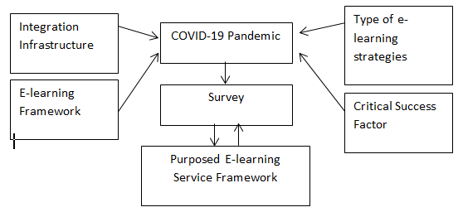
Figure 1 Research Method

In this research, using the central "COVID-19 Pandemic" issue," and then related by the theories that support the development of the e-learning service framework. Furthermore, before designing the E-learning Service Framework, the author also considers the results of the survey, both the survey of the Indonesian Internet Service Providers Association (APJI) and the survey conducted by the author of Informatics Engineering students at Universitas Muhammadiyah Magelang. As validation, information from the survey results will verification the E-learning Service Framework at COVID-19 Pandemic.

Literature Study
In its development, the application of e-learning systems has entered the Industrial 4.0 era, where this affects the development of education termed Education 4.0, which has the characteristic of the role of Artificial Intelligence [2] . And as a recent development, the evolution of the e-learning system has entered e-learning 3.0 in harmony with Education 4.0 which gave rise to the concept of u-learning [1].

  - Indonesian Task Force for COVID-19 Rapid Response
A coordinated response is critical. The first significant regulation is the formation of the Task Force for Rapid Response to COVID-19 (Gugus Tugas Percepatan Penanganan COVID-19) on 13 March 2020 until regulation Big Scale Social Restriction on 31 March 2020 as Government Regulation No 21/2020 [3]. One of the roles and responses to regulation above is to focus on digital and media thrives under COVID-19, where the role of the digital platform is to support working from home. In the world of digital education in Indonesia, one of them is Ruangguru, which provides content for secondary and primary education. However, inadequate infrastructure and the ability to access the internet require alternative ways to continue implementing online learning by adjusting the situation.

  - E-learning Framework
In the development of the definition of e-learning system can be explained as a web application in the education sector with stakeholder students, teachers, academic staff, and ICT staff[4]. The four stakeholders depend on internet access with the teacher's role as the leading player in connecting systems that adapt to the methods of student learning. Besides that, there is the role of school management that is taking the steps needed to increase student and teacher knowledge in the effective use of the system.
To explain the relationship between stakeholders is described in the form of a framework. In [5] being explained, a concept of the e-learning framework in secondary school is in the form of LearnCube. The success factor of e-learning in LearnCube consists of 6 dimensions, as shown below:

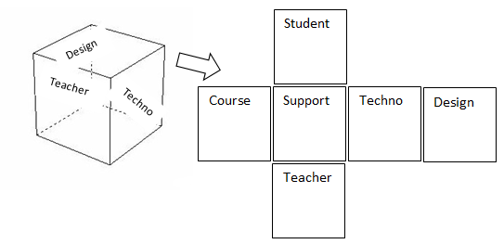

Figure 2 Adaptation of modeling LearnCube

This modeling is a concept proposed in secondary schools, but several sections are relevant to other levels of education. This modeling can be to explain the inter-relations between dimensions. This modeling becomes the conceptual framework of the e-learning system.
Referring to the discussion of E-learning 3.0 generation where the use of mobile technology (cellular) technology is very dominating. Adopting LearnCube above in the E-learning era on pieces related to Techno (Technology), the direction is collaborative, semantic web and Ubiquitous with the support of mobile technology [1].
The implementation of e-learning 3.0 is practically all internet-based, so its management is known as the Education Management System (EMS) [6]. The three roles of the EMS are: Students, Teachers, and also Administration who will be in contact with university servers and other learning activities via the internet in the form of cloud infrastructure. The administrative roles of the three roles are into two, namely administration of the academic field called staff and administration of the IT support field called admin.
In cloud services can be categorized at two layers, namely the User Layer and IT Layer. Each of these layers has two resources, namely Physical Resurrection, which is often known as Infrastructure and Virtual Resources, which are often also called middleware layers in the form of application services in the cloud, known as Education as a Service (EaaS).
In the cloud-based e-learning system architecture, there are two types of cloud, namely private cloud, which is the property of the university, and public cloud provided by providers such as EaaS. Both types of cloud are connected and to access them will be through a cloud management system with module authentication [7].
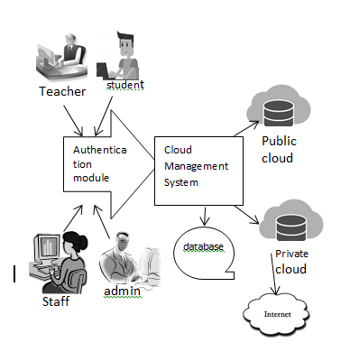

Figure 3 Achitecture Interactive Mode [7]

  - Type of e-learning strategies
The process of education becomes the most crucial part of the development of educational institutions. Like the education process, the e-learning system is also a strategy in the development of institutions. In [8] explained the types of e-learning strategies, namely:
- The Strategic of electronic lecture: strategy in continuously developing learning content that is suited to the needs of students.
- E-Learning interactive private education: strategies that break down the material into small modules that can provide a sustainable, interactive system.
- Working Group: student learning strategies together in groups to solve a problem.
- Electronic discussion: strategies prepared in an e-learning system environment for mutual interaction.
- E-Brainstorming: is an activity to stimulate students' thinking power.
- Solving electronic problems: helping students to understand the basic concepts of knowledge to improve behavior in researching.
- Electronic simulation (imitating): is a representation of a real situation that is difficult for students to learn[9].
- Interactive Environment: is an application based on computer technology, networks, and multimedia in order to achieve goals in the learning process.
- Self-directed education electronically: is communication between a student and the teacher in private without any other participation.
- E-Project Strategy: the use of web-based tools for collaboration in learning.
- E-Deployment Strategy: The use of computer hardware and systems for innovation, creativity, and model production in learning.
- E-Learning Strategy: Teaching formula that depends on the pattern desired by students with the assistance of the teacher.
- E-Learning Collaborative Strategies: an interactive method that allows students to partner with other students to build learning in a specific schedule.
Taking into account the state of the two roles, namely instructors and students, becomes essential in implementing e-learning strategies. In this pandemic COVID-19 situation, both roles must use personal property.

  - Critical Success Factor
Changes in the e-learning system framework that previously depended entirely on the resources of the institution [10], which is often termed traditional e-learning into an e-learning system framework that has been developed by considering the Critical Success Factors. Referring to [11] there are eight categories of critical success factors, which areas in the following figure:
Critical Success Factor Affecting to Implement E-Learning in Higher Education
technological factors
Institutional factor
Resource factor
Social Interaction factor
Evaluation factor
Ethical Factor
Pedagogical factor
Management Factor

Figure 4 Conceptual framework on the critical success factors affecting to implement e-learning in higher education

From the eight success factors above, the sub-factors explained as follows: Technological Factor with sub-factor infrastructure planning, hardware, and software. Institutional Factors with sub-factors of financial readiness, Infrastructure readiness, cultural readiness, and content readiness. Pedagogical Factors with sub-factors attitudes towards students, technical competence, context interaction. Management Factors with the subfactor management team, managing the content development process, managing delivery, and maintenance. Ethical Factors with social and political influence subfactors, cultural, diversity, bias, geographical diversity, learner diversity, digital divide, etiquette, legal issues. Evaluation Factors with sub-factor evaluation and assessment, course evaluation, learners' learning assessment. Resources Factors with sub-factor ownership of computers and availability, Internet access, computer competency, fluctuating, and unreliable electricity supply. Social Interaction Factors with sub-factors lack social interaction, lack of cultural interaction, isolation and, decreased motivation.
As a discussion in the case of the pandemic COVID-19, the factors above will be discussed very relevant factors. Because of technological developments in end-users (students and teachers), it is necessary to have an e-learning flexibility system that can be used in a variety of devices (multi-platform) [12]

  - Integration Infrastructure
Infrastructure in the e-learning system is an essential factor to consider in student satisfaction. Although the quality of content is the tendencies for students [13], but this time the discussion led to the integration of infrastructure.
The purpose of building a system integration framework consists of two aspects, first providing a function to maintain the consistency and effectiveness of heterogeneous systems to achieve interoperability, secondly finding frameworks that can be combined flexibly, easily expanded to meet new requirements quickly, with which new information systems can quickly be integrated [14].
There are five categories in modeling the integrated infrastructure system, one of which is network-based approaches [15]. Network-based approaches used to model integrated infrastructure systems, where nodes represent different infrastructure components, and links represent different interdependencies between systems. In developing, systems infrastructure integration needs to pay attention to the social impact and behavioral dimensions.
Students and instructors in the e-learning system are components that utilize the system, while school management, which consists of academic managers and IT support administrators, is a crucial component for achieving an active system [4]. Therefore, in this Infrastructure Integration component that becomes the role is the Educator/teacher, students, and school management.
  - Assessment e-learning
It is essential to create a system to assess students, which take into account the educational goals and help students to develop their skills which will be a useful for the society for long-term [16] these challenges and suggested solutions: Students who lack experience with ICT, access to computers and the internet. Infrastructure development, Difficulties in correction and scoring, Group work assessment, lack of information about technology educators.
From the description referred to in the discussion of infrastructure integration above, it can group into components that must integrate, namely:

Table 1 Role, challenges and Recommendation in assessment
Role | Challenge | Recommendation (type E-learning strategy)
Instructor/Teachers | Not familiar with technology | Uses cloud provider application which consider for user friendly
 | Difficulty of correcting and scoring
 | Teamwork scoring
Student | Less experienced with ICT | The application refer to availability and capacity of student ICT, like as cellular platform
 | Computer and Internet Access
Institution | infrastructure develop | The institution mean are academic staff and administrator support system which base on private cloud, although teacher and student use public cloud

Discussion
In this research, as central is of the issue of "COVID-19 Refer to situation COVID-19 Pandemic, e-learning systems become an alternative means of active learning. Students and Lecturers carry out learning independently from home with the use of personal devices. However, the lack of infrastructure and also the lack of integration are challenges in its implementation.
Based on Indonesia's national survey infographic about internet usage behavior [17] , the device used to access the internet daily 93.9% is a smartphone, and the biggest reason for internet access is for social media. Also, a survey of students in the Informatics study program at the Universitas Muhammadiyah Magelang.
The Univerisitas Muhammadiyah Magelang is located in the middle of the island of Java, precisely in the province of Central Java with a distance of 70 Km from the capital city of the province of Semarang and 45 Km from the city of Jogyakara province of the Special Region of Yogyakarta (DIY). It is a mountainous area and is a rural area with a growth of 5.43% pertumbuhan 5.43% [18].
The choice of the first year Informatics study program because it used as a benchmark of ability in the IT field that can be classified as medium level, the number of respondents was 98 students. The question posed is representative of the statement in developing a framework.

Table 2 Questioner and Objective
Questioners |  | objective
Q1 | The Cellular brand | the purchasing power of technology | O1
Q2 | Size Cellular Memory | Technology ability | O2
Q3 | Cellular provider | Infrastructure availability | O3
Q4 | Prepaid or postpaid | User type | O4
Q5 | For Postpaid : monthly for cellular | Estimate bandwidth uses | O5
Q6 | For Prepaid : top up per moth | Estimate bandwidth uses | O6
Q7 | How internet access from home | Home Infrastructure | O7
Q8 | Massager app at home | Synchronous method | O8
Q9 | Social media access at home | Activity Internet at home | O9
Q10 | How often watch youtube | Time for watching video for capability of cost | O10

From the survey questions obtained data and concluded:

Table 3 Questioner, Data and Resume
Questioners | data | Conclusion
Q1 | 79.5% Chose the brand of cellular are under Rp 2.500.000 | device type is medium
Q2 | RAM (memory) >= 2GB = 67% | device capability is adequate
Q3 | 55.7 % uses reputable cellular provider | The student residence is affordable by a stable network
Q4 | 84.1% prepaid
Q5 | Cost less than Rp 150,000 | Internet capacity 2 GB
Q6 | 51.4% cost range Rp 50,000 – Rp 100,000 | Internet capacity 2 GB
Q7 | 66.5% tethering by cellular | The internet access method is to use cellular
Q8 | 94.3% app. Whatsapp user | Messenger application that can be used as Synchronous communication
Q9 | 59.1% Istagram user | social media that is often accessed
Q10 | 31.8% always access youtube at home, and 40.9% sometimes access youtube at home. | bandwidth capability at home

From the two survey results above, the table illustrates the ability of students to technology in this e-learning system. The ability in question is the financial ability and ability to support the implementation of e-learning systems. In terms of financial capability, most of the users are 2 GB monthly packages, although some use the internet at home. In terms of technology, the average hardware is adequate, but the performance of internet access must also review the infrastructure of the cellular service provider.
Following this review of the eight critical success factors, to direct the discussion of the framework, proposed relationships with e-learning users are elaborated into four roles. The following is the table:

Table 4 Relationship 8 factors and responsibilities 4 roles in e-learning systems
8 Critical Success Factor | Teacher | Student | Staff | Administrator
Technological Factor | √ | √ | √ | √
Institutional Factors |  |  | √ | √
Pedagogical Factors | √
Management Factors | √ |  | √ | √
Ethical Factors |  |  | √ | √
Evaluation Factors | √ |  | √ | √
Resources Factors | √ | √ | √ | √
Social Interaction Factors | √ | √

From the table above, each critical success factor can explain its relation to the role in e-learning systems. The technological Factor has relations for all roles in e-learning systems. Likewise, for Institutional Factor, Teachers and Students do not have the authority, so it is not considered to have a relationship.
However, in the COVID-19 Pandemic of 8 Critical Success Factors, the most important factors or priority factors were chosen in dealing with this pandemic. These are factors aimed at overcoming Infrastructure and Integration issues, so five factors are chosen; Technological Factor Institutional Factor, Management Factor, Evaluation Factors, and Resources Factors.

Table 5 A proposed 5 Critical Factors for E-learning in COVID-19 Pandemic
5 from 8 Critical Sucsess Faktor on COVID-19 Pendemic | Teacher |  | Student |  | Staff | Administrator
Technological Factor | √ | √ |  | √ |  | √
Institutional Factors |  |  |  | √ |  | √
Managemennt Factors | √ |  |  | √ |  | √
Evaluation Factors | √ |  |  | √ |  | √
Resources Factors | √ | √ |  | √ |  | √

- Resume
Based on the discussion above, from the results of both national and small scale surveys at the University of Muhammadiyah Magelang and reviewing of 8 success factors, a framework for implementing the e-learning system into five success factors was proposed. By prioritizing the implementation of learning using technology owned by both at affordable costs. The following are the proposed E-learning service frameworks, in which e-learning system architecture was developed by emphasizing five critical success factors. In terms of cloud computing, it can explain the use of cloud models in the following table:

Table 6 Cloud Infrastructure for Critical Sucsess Factor
5 from 8 Critical Sucsess Faktor on COVID-19 Pendemic | Teacher | Student | Staff | Administrator
Technological Factor | Public cloud | Public cloud | Public cloud | Public cloud
Institutional Factors |  |  | Private cloud | Private cloud
Managemennt Factors | Public cloud |  | Private cloud | Private cloud
Evaluation Factors | Public cloud |  | Private cloud | Private cloud
Resources Factors | Public cloud | Public cloud | Private cloud | Private cloud

Specifically for Resource Factors, a bridge is needed that connects instructors to institutions (admin and staff). So that, when described in the architectural form, is as follows:
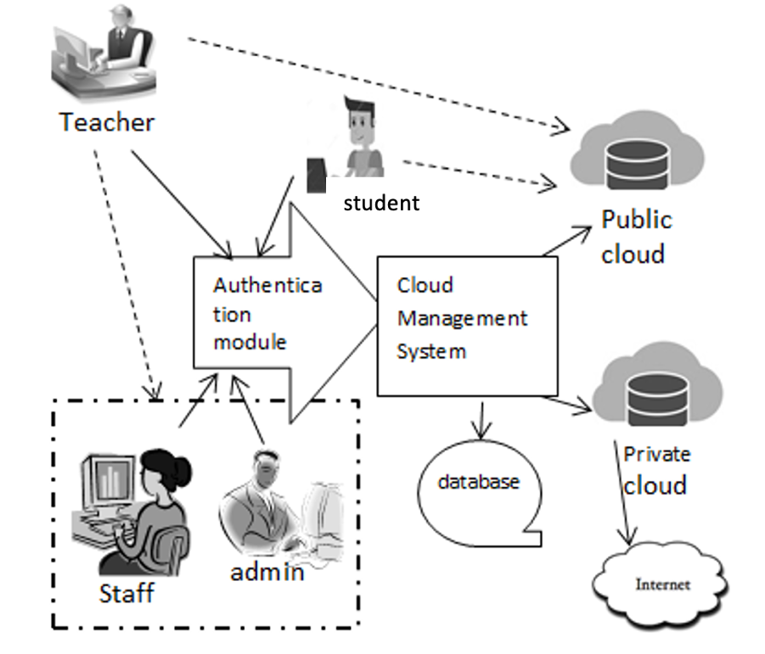
Figure 5 Propose Architecture of Simple E-Learning System For COVID-19 Pandemic

Conclution
E-learning Service Framework in the Work from Home period must consider five of the eight critical success factors. Of the five critical success factors, two of them are Technology Factor and Resource Factor, which are of concern to teachers, students, academic staff, and IT administrators.
In COVID-19 Pandemic, the priority is the implementation of learning from teachers to students, therefore by considering Technology Factor and Resource Factor, the use of public cloud with bandwidth requirements can be adjusted to the infrastructure, ability, and allocation of student costs. At the same time, the integration problem using the application provided on the public cloud where the implementation is when the instructor reports to the institution (staff and Admin) to the instructor.

Reference
[1] P. Miranda, P. Isaias, and C. J. Costa, “E-Learning and Web Generations : Towards Web 3 . 0 and E-Learning,” Int. Proc. Econ. Dev. Res., vol. 81, pp. 92–103, 2014, doi: 10.7763/IPEDR.2014.V81.15.
[2] P. Hendradi, M. Khanapi, and S. N. Mahfuzah, “Cloud computing-based e-learning system architecture in education 4.0,” J. Phys. Conf. Ser., vol. 1196, no. 1, pp. 0–7, 2019, doi: 10.1088/1742-6596/1196/1/012038.
[3] R. Djalante et al., “Review and analysis of current responses to COVID-19 in Indonesia: Period of January to March 2020,” Prog. Disaster Sci., 2020, doi: 10.1016/j.pdisas.2020.100091.
[4] A. K. M. N. Islam, “E-learning system use and its outcomes: Moderating role of perceived compatibility,” Telemat. Informatics, vol. 33, no. 1, pp. 48–55, 2016, doi: 10.1016/j.tele.2015.06.010.
[5] S. Haw and M. M. U. Cyberjaya, “Conceptualize the e-Learning Framework for the Secondary School Curriculum,” in Proceedings of the International Conference on Digital Technology in Education, 2017, pp. 18–22, doi: 10.1145/3134847.3134851.
[6] S. Pattanayak, S. Mohapatra, and S. Mohanty, Empowering of ICT-Based Education System Using Cloud Computing. Springer Singapore, 2019.
[7] M. A. H. Masud and X. Huang, “An e-learning system architecture based on cloud computing,” System, pp. 74–78, 2012, doi: 10.1.1.221.4704.
[8] S. A. M. Abdalmenem, S. S. Abu-Naser, M. J. Al Shobaki, and Y. M. Abu Amuna, “Relationship between e-Learning Strategies and Educational Performance Efficiency in Universities from Senior Management Point of View,” vol. 3, no. 6, pp. 1–7, 2019.
[9] A. A. Al hila, M. J. Al Shobaki, S. S. Abu Naser, and Y. M. Abu Amuna, “Proposed Model for Learning Organization as an Entry to Organizational Excellence from the Standpoint of Teaching Staff in Palestinian Higher Educational Institutions in Gaza Strip,” Int. J. Educ. Learn., vol. 6, no. 1, pp. 39–66, 2017, doi: 10.14257/ijel.2017.6.1.05.
[10] G. Riahi, “E-learning systems based on cloud computing: A review,” Procedia Comput. Sci., vol. 62, no. Scse, pp. 352–359, 2015, doi: 10.1016/j.procs.2015.08.415.
[11] S. K. Basak, M. Wotto, and P. Bélanger, “A Framework on the Critical Success Factors of E-Learning Implementation in Higher Education : A Review of the Literature,” no. August, 2017.
[12] I. Salamah and M. A. Ganiardi, “Development of e-learning software based multiplatform components,” Bull. Electr. Eng. Informatics, vol. 6, no. 3, pp. 228–234, 2017, doi: 10.11591/eei.v6i3.647.
[13] S. Sfenrianto, E. Tantrisna, H. Akbar, and W. Mochamad, “E-learning effectiveness analysis in developing countries: East nusa tenggara, Indonesia perspective,” Bull. Electr. Eng. Informatics, vol. 7, no. 3, pp. 417–424, 2018, doi: 10.11591/eei.v7i3.849.
[14] O. Noran, “Building a support framework for enterprise integration,” Comput. Ind., vol. 64, no. 1, pp. 29–40, 2013, doi: 10.1016/j.compind.2012.09.006.
[15] S. Saidi, L. Kattan, P. Jayasinghe, P. Hettiaratchi, and J. Taron, “Integrated infrastructure systems—A review,” Sustain. Cities Soc., vol. 36, pp. 1–11, Jan. 2018, doi: 10.1016/j.scs.2017.09.022.
[16] N. Alruwais, G. Wills, and M. Wald, “Advantages and Challenges of Using e-Assessment,” Int. J. Inf. Educ. Technol., vol. 8, no. 1, pp. 34–37, 2018, doi: 10.18178/ijiet.2018.8.1.1008.
[17] APJII, “Penetrasi & Profil Perilaku Pengguna Internet Indonesia Tahun 2018,” Apjii, p. 51, 2019, [Online]. Available: www.apjii.or.id.
[18] Suhariyanto (Badan Pusat Statistik), Produk Domestik Regional Bruto Kabupaten/Kota Di Indonesia. Jakarta: Badan Pusat Statistik, Jakarta-Indonesia, 2019.

